Title, Author, and Genre:

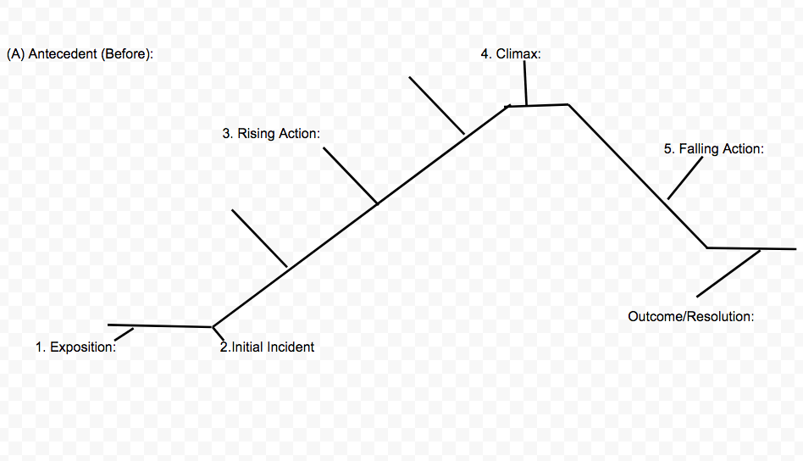
Person + External/Internal Conflict + Change (or Inability to Change) = Effects on Self and/or Others
Character(s) Traits and Motives:
____________________________________________________________________________________________________________________________________________________________________________________________________________________________________________________________________________________________________________________________________________________________________________________________________________________________________________________________________________________________________________________________________________________________________________________________________________________________________________________________________________________________________________________________
Important Quotes and Who Said It:
________________________________________________________________________________________________________________________________________________________________________________________________________________________________________________________________________________________________________________________________________________________________________________________________________________________________________________________________________________________________________________________________________________________________________________
__________________________________________________________________________________________________________________________________________________________________________________________________________________
Techniques:
____________________________________________________________________________________________________________________________________________________________________________________________________________________________________________________________________________________________________________________________________________________________________________________________________________________________________________________________________________________________________________________________________________________________________________________________________________________________________________________________________________________________________________________________
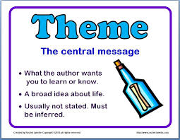
Theme(s):
__________________________________________________________________________________________________________________________________________________________________________________________________________________________________________________________________________________________________________________________________________________________________________________________________________________________________________________________________________________________________________

