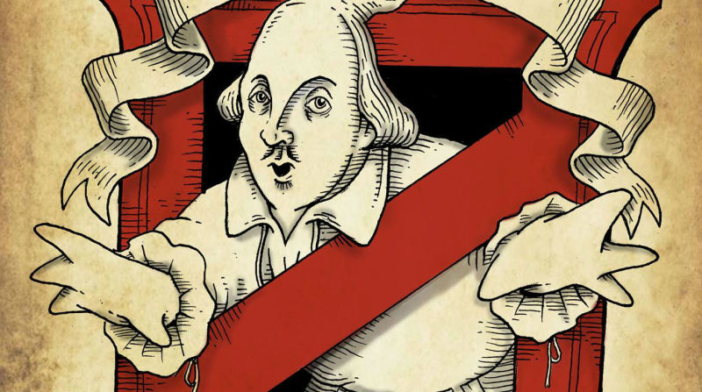
Shakespeare in Minutes

You will be divided into your groups.

1. Your task is read through the synopsis that is provided.

2. Next you will work with the text of Macbeth and find the 3 most important quotes in the your scene.
Helpful tip: this is deep text with lots of layers and happenings. It would be wise to use quotes that are able to both concisely and thoroughly reflect the significance of the scene.
Think about plot, theme, characterization---what do we learn from your quote

3. You will write down your chosen quotes
i. Use proper citation
4. You will act out your scene (2-3 minutes)
- As you act out your scene, which can be in modern English, you will need to say your three quotes as part of your performance.
- Once your performance is over, you will explain to the class why you choses those specific lines and what they reveal

Act 1
Performance – 1 2 3 4 5
Significance/Accuracy of Quotes- 1 2 3 4 5
Act 2
Performance – 1 2 3 4 5
Significance/Accuracy of Quotes- 1 2 3 4 5
Act 3
Performance – 1 2 3 4 5
Significance/Accuracy of Quotes- 1 2 3 4 5

Act 4
Performance – 1 2 3 4 5
Significance/Accuracy of Quotes- 1 2 3 4 5
Act 5
Performance – 1 2 3 4 5
Significance/Accuracy of Quotes- 1 2 3 4 5

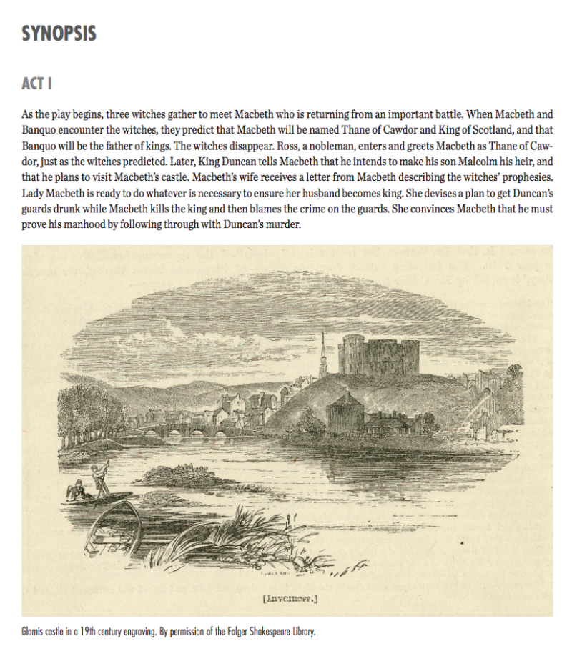

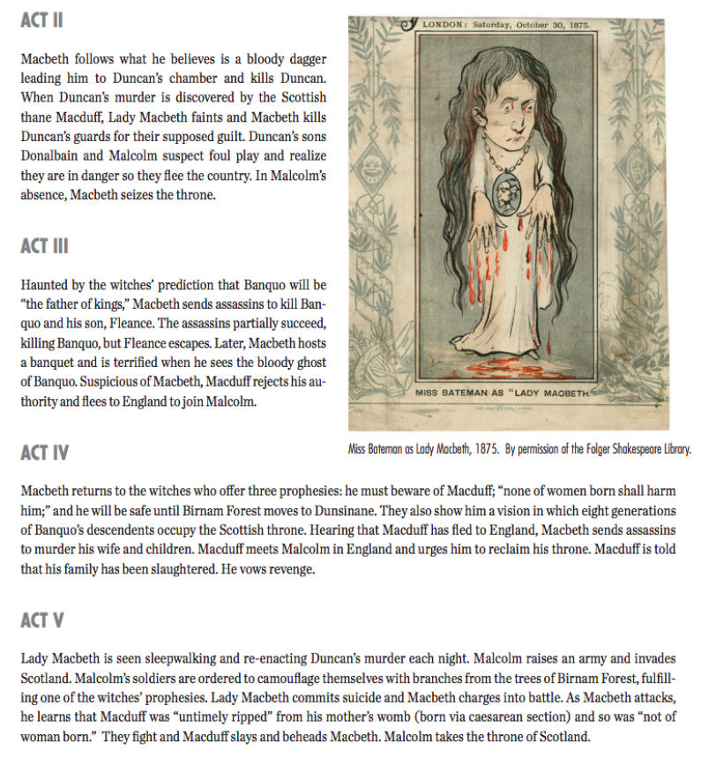

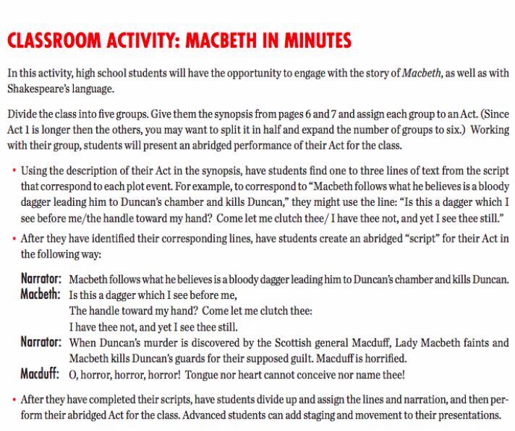
Repeat for ACT2-Act 5

