PRACTICE ESSAY QUESTIONS
How does a person’s alienation reveal the values and assumptions of that culture or society?

- Define Key Words:
__________________________________________________________________________________________________________________________________________________________________________________________________________________
Key Word: _____________; Synonym: __________________, ____________________
- What is the stem/root of the question asking:
How do:
____________________________________________________________________________________________________________________________________________
- Put the question into your own words:
____________________________________________________________________________________________________________________________________________

Discuss the tension between outward conformity and inward questioning.

- Define Key Words:
__________________________________________________________________________________________________________________________________________________________________________________________________________________
- Key Word: _____________; Synonym: __________________, ____________________
- What is the stem/root of the question asking:
How do:
____________________________________________________________________________________________________________________________________________
- Put the question into your own words:
____________________________________________________________________________________________________________________________________________

What are the effects from the ways in which individuals try to live in a society with governing rules and systems?
- Define Key Words:
__________________________________________________________________________________________________________________________________________________________________________________________________________________
- Key Word: _____________; Synonym: __________________, ____________________
- What is the stem/root of the question asking:
How do:
____________________________________________________________________________________________________________________________________________
- Put the question into your own words:
____________________________________________________________________________________________________________________________________________
Discuss an individual’s ability to adapt to situations in his/her life. What idea(s) does the writer develop regarding adaptation?

- Define Key Words:
__________________________________________________________________________________________________________________________________________________________________________________________________________________
- Key Word: _____________; Synonym: __________________, ____________________
- What is the stem/root of the question asking:
How do:
____________________________________________________________________________________________________________________________________________
- Put the question into your own words:
____________________________________________________________________________________________________________________________________________

Thesis: In the _________, ___________, the __________
(genre) (title) (author’s name)
use of_______________ suggests the idea that____________________.
(technique: character development) (topic & student’s focus/controlling idea)

Possible Techniques:
-Character development (traits/motives/desires/challenges/ etc.)
-Character types (dynamic/flat/static/foil/ etc.)
-Actions and consequences
-Symbolism and motifs
-Time and place
-Archetype
-Showself
-Irony
-Conflict
-Paradox
-Others???
Controlling Idea: Examine the characters of the piece and explain what they reveal about your controlling ideas.

Examples: Given Topic: Adversity
Given the general topic of adversity a thesis statement may be:

In the play A Doll’s House, Heinrich Ibsen ‘s use of character development suggests the idea that adverse situations have the power to blow the monotonous continuum of one’s life to pieces and consequently may spur a search for personal identity.
Note: the basic parts
a) title- A Doll’s House
b) author’s name – Heinrich Ibsen
c) genre – play
d) technique – character development
e) topic – adversity
f) focus/controlling idea - Adverse situations have the power to blow the monotonous continuum of one’s life to pieces and consequently may spur a search for personal identity.

Sample Thesis statements
1. In the short story “Gaston,” William Sarayan makes powerful use of character development to suggest the idea that appearances are frequently unreliable and do not reveal one’s inner self.

2. In Shakespeare’s play Hamlet, the title character is used to demonstrate the idea that one must discover his own moral beliefs before he sets out to accomplish his goals.

3. The idea that one must cling to hope in the face of adversity is apparent through the development of the protagonists in the film Life is Beautiful by Roberto Benigni and the biography Night by Elie Weisel.

4. Through the contrasting characters of Willy and Biff, Arthur Miller in the modern drama Death of a Salesman, examines the idea that for some people, the desire to escape the harshness of life is stronger than the need to confront reality.

Whenever you are thinking about a literary essay…
YOU MUST discuss HOW or WHY the character changes (psychologically, philosophically, or physical) or stays stagnant, AND what is the impact (personal, others, or societal).
Physical-connection to real world, relationships, environment, etc.
Philosophical-Beliefs
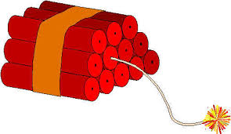
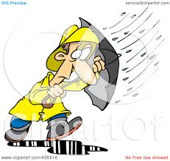
Experience/Conflict
(External or Internal)
Change
(philosophically, emotionally, physically)

Consequences
Effect on self or others

If a character is flat and remains stagnant YOU MUST discuss
Experience/Conflict
(External or Internal)
Inability to Change
(philosophically, emotionally, physically)

Consequences
Effect on self or others

When we examine conflict, we have to think about intrinsic and extrinsic motivation:
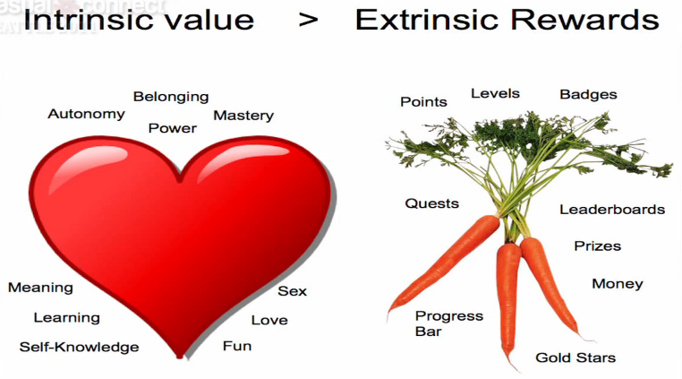
When we examine conflict, we have to think about intrinsic and extrinsic motivation:

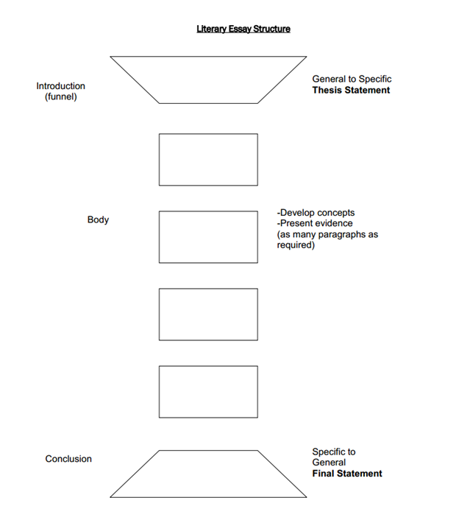
ESSAY Writing
List four different types of hooks:
1. ___________________________________________
2. ___________________________________________
3. ___________________________________________
4. ___________________________________________
Parts of the Essay:
1. Introductory paragraph:
a. ___________________________________________________
b. ___________________________________________________
c. ___________________________________________________
d. ___________________________________________________

2. Body paragraphs:
. ___________________________________________________
a. ___________________________________________________
b. ___________________________________________________
c. ___________________________________________________
d. ___________________________________________________

3. Conclusion:
. ___________________________________________________
a. ___________________________________________________
b. ___________________________________________________
c. ___________________________________________________
What type of language should be avoided? Hint they start with…
I sta______ such as ______________, _______________, and ______________
Ab__________ such as ______________, _______________, and ___________
Sl________________ and Con_______ such as ______________, _______________, and __________________

