POETRY TERMS
*These terms may appear on both vocab quizzes and on your unit exam. You must not only know the definition, but you must be able to understand them in poetry.
Term | Definition | YOUR Example | Picture/Symbol
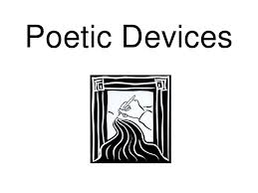
Simile | z
Metaphor
Personification
Hyperbole
Mood
Juxtaposition
Litotes
Metonymy
Synecdoche
Stanza
Alliteration
Assonance
Consonance
Onomatopoeia
Euphony
Cacophony
Rhyme
Dissonance
Meter
Feet
Extended Metaphor
Free Verse
Couplets
End Stop
Enjambment
Apostrophe
Audience
Ballad
Internal Rhyme
Elegy
Epic
Euphemism
Irony:
Situational/Dramatic/ Verbal
Iambic Pentameter
Internal Rhyme
End Rhyme
Persona
Literal vs Figurative Language
Octave
Pastoral
Speaker
Ode
Sonnet

