Step 1:
Start off with breaking down the question
Put it into your own words
Ask what is the importance of the topic
Have at least 3 synonyms for each key term
Mind Map???
Step 2:
Venn diagram
Step 3
Thesis development
Step 4:
Outline of point
Mind map?

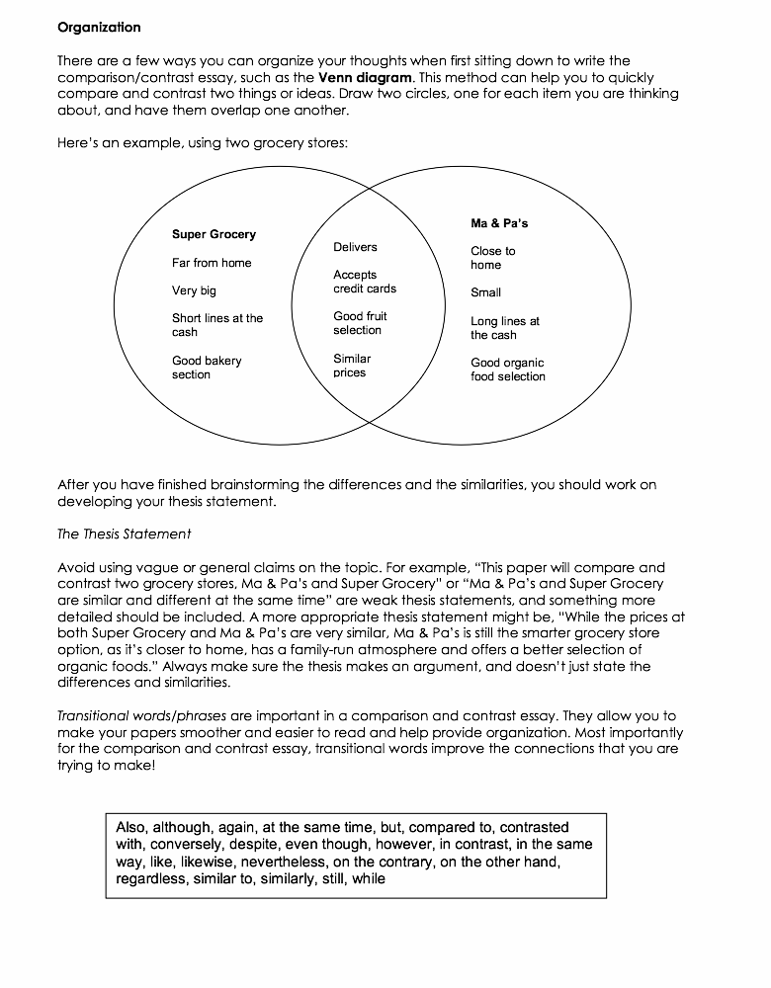
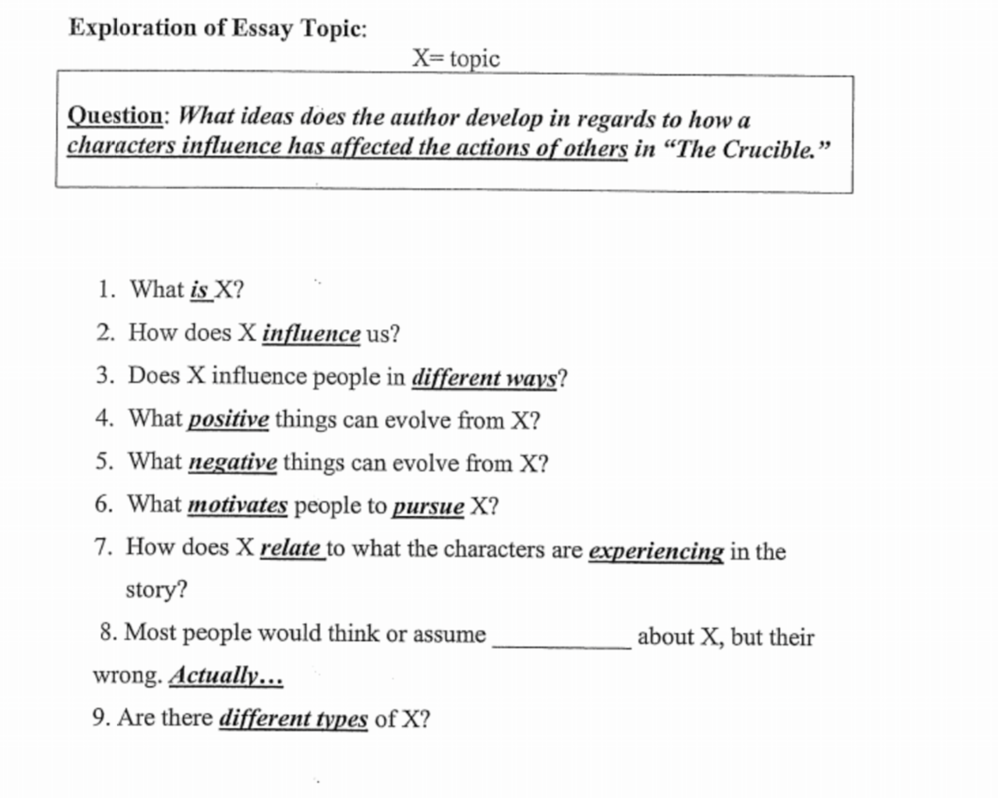

1. What is X?
2. How does X Influence us?
3. Does X influence people in different ways?
4. What positive things can evolve from X?
5. What negative things can evolve from X?
6. What positive things can evolve from X?
7. How does X relate to what the characters are experiencing in the story?
8. Are there different types of X?

THESIS PRACTICE

 | BAD THESIS | GOOD THESIS
Is it CLEAR? | Although the timber wolf is a timid and gentle animal, it is being systematically exterminated. [if it's so timid and gentle -- why is it being exterminated?]
Do NOT make it GENERAL. | There are serious objections to today's horror movies
Is it INTERESTING and ORIGINAL? | There are advantages and disadvantages to using statistics.
Does it answer the SO WHAT question? | Shakespeare uses irony to show Macbeth’s greed.

Controlling Idea: Examine the characters of the piece and explain what they reveal about your controlling ideas.

Examples: Given Topic: Adversity
Given the general topic of adversity a thesis statement may be:

In the play A Doll’s House, Heinrich Ibsen ‘s use of character development suggests the idea that adverse situations have the power to blow the monotonous continuum of one’s life to pieces and consequently may spur a search for personal identity.
Note: the basic parts
a) title- A Doll’s House
b) author’s name – Heinrich Ibsen
c) genre – play
d) technique – character development
e) topic – adversity
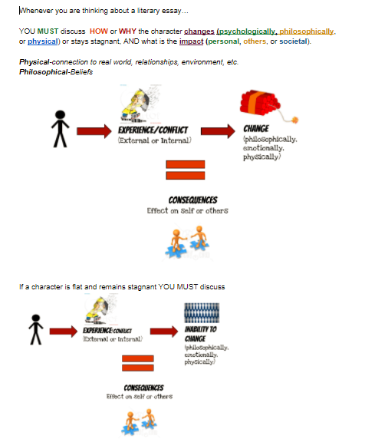
f) focus/controlling idea - Adverse situations have the power to blow the monotonous continuum of one’s life to pieces and consequently may spur a search for personal identity.

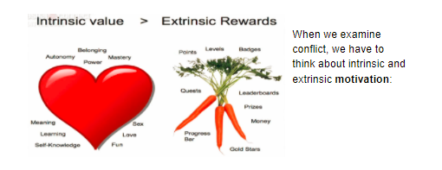

COMPARATIVE ESSAY OUTLINE TEMPLATE
INTRODUCTORY PARAGRAPH FORMAT
Insightful Idea + Text 1 + Qualifier in Text 1 + Text 2 + Qualifier in Text 2.

- Format 1 Different
(SAME topic but DIFFERENT) text 1 + text 2 = topic/similar; however, topic/different = insight
OR
- Format 2 (SIMILAR)
text 1 + text 2 = topic/similar = insight

Format 1 Different
(SAME topic but DIFFERENT) text 1 + text 2 = topic/similar; however, topic/different = insight
Hook: _____________________________________________________________________________.
Context sentence:_______________________________________. Text 1____________________________by ____________________ and text 2____________________
by________________. both deal with the main idea/topic of_______________________________. However, (text1)__________________ shows us through the development of (character/qualifier/circumstance/device)_________________________
that (result) __________________________________________________________________________. Whereas (text2)_______________________demonstrates (result)______________________________
______________________________________ through (character/qualifier/circumstance/ device) ____________________________________________________________________________________.

Your turn:
__________________________________________________________________________________________________________________________________________________________________________________________________________________________________________________________________________________________________________________________________________________________________________________________________________________________________________________________________________________________________________________________________________________________________________________________________________________________________________________________________________________________________________________________________________________________________________________________________________________________________________________________________________________________________________________________________________________________________________________________________________

OR

Format 2 (SIMILAR)
text 1 + text 2 = topic/similar = insight
Hook: _________________________________________________________________________.
Context sentence: _______________________________________________________________.
(Text 1)___________________by _______________________ and (Text 2) _________________
by_____________________ both deal with the main idea/topic of___________________________________________________________. In each piece (one/individual/reader, etc. ) can see how (character/qualifier/circumstance, etc.) _______________________________________________________determines________________________________. This__________________ is shown/revealed with (character/event/conflict/outcome)
_______________________________________________________in (text1)___________________
and (character/event/conflict/ outcome) _______________________________________________
in (text 2)_______________________________________.
Your turn:
__________________________________________________________________________________________________________________________________________________________________________________________________
__________________________________________________________________________________________________________________________________________________________________________________________________
__________________________________________________________________________________________________________________________________________________________________________________________________
____________________________________________________________________________________________________________________________________________________________________________________________________________________________________________________________________________________________________________________________________________________________________________________________________

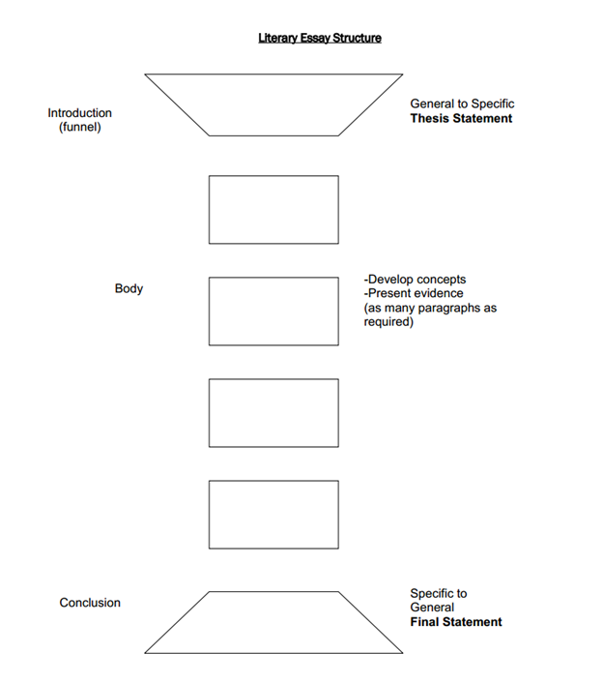
Body Paragraphs:
M.E.A.L or T.E.E.C.
Main idea (text 1) demonstrates/reveals etc. ____________________ through _______________.
Introduce evidence, “evidence”.
Analyze evidence and text
Link your paragraph back to your thesis
FORMAT 1
Introductory Paragraph
Main Idea A
Text 1
1. Example:
2. Analysis:
Text 2
3. Example:
4. Analysis:
5. Link to thesis (how your paragraph proves your point/thesis)
Main Idea B
Text 1
1. Example:
2. Analysis:
Text 2
3. Example:
4. Analysis:
5. Link to thesis (how your paragraph proves your point/thesis)

Conclusion
1.Restate your points
2. Restate your thesis
3. Clincher Statement

FORMAT 2
Introductory Paragraph
Introduce Text 1
1. Example:
2. Analysis:
3. Example:
4. Analysis:
5.Link to thesis (how your paragraph proves your point/thesis)
Introduce Text 2
1. Example:
2. Analysis:
3. Example:
4. Analysis:
5. Link to thesis (how your paragraph proves your point/thesis)
Conclusion
Restate your points
Restate your thesis
Clincher Statement ---extension statement

