3 Characters Activity

Please draw three characters.

- In addition to your drawing, provide at least one descriptive paragraph for each character.

- Each descriptive paragraph should use as much vivid detail as possible.

- Each of your descriptive paragraph/s should have a minimum of five sentences.

- You must identify each character as a specific character type and identify each character’s main motivation.

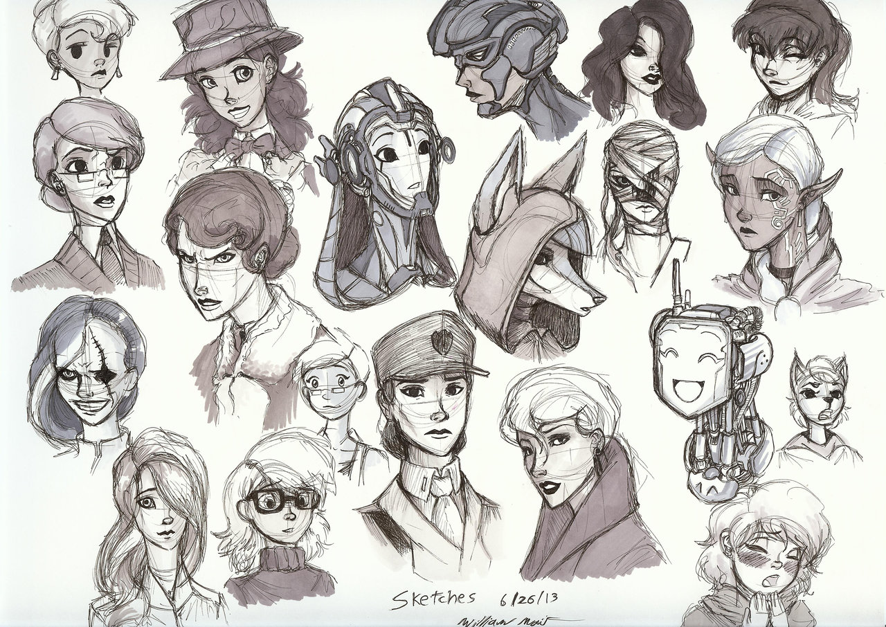

Assignment Rubric:

 | 4 | 3 | 2 | 1
Content  Organization | The student’s paragraph is extremely descriptive and creates a vivid picture in the reader’s mind.  The paragraph is well organized. | The student’s paragraph is descriptive and effectively portrays the character.  The paragraph is fairly well organized. | The student’s paragraph is somewhat descriptive.  The paragraph is poorly organized. | The student’s paragraph has little or no useful description of the character’s traits and appearance.  The paragraph has little to no organization.
Conventions  Sentence Structure | Sentence structure is consistently varied and controlled.  The quality of the writing is excellent in that it contains few or no errors in  conventions. | Sentence structure is generally varied and controlled, but errors may occasionally  impede meaning.  The quality of the writing is sustained through generally correct use of  conventions. | Sentence structure is sometimes varied and controlled, but errors  impede meaning.  The quality of the writing is weakened by the frequently incorrect use of conventions. | Sentence structure is not controlled, and errors often  impede meaning.  The quality of the writing is impaired by the consistently incorrect use of  conventions.

Total: /16

