1984 Literary Techniques
Term | Your Definition | Example from the text and Significance
- Antithesis
- Dystopia

- Irony

- Metaphor

- Objective correlative
- Oxymoron
- Parable
- Paradox
- Satire
- Symbolism
- Verisimilitude

Literary Connections
What is Happening in the Book | Similarities to Today’s Society

Title, Author, and Genre:

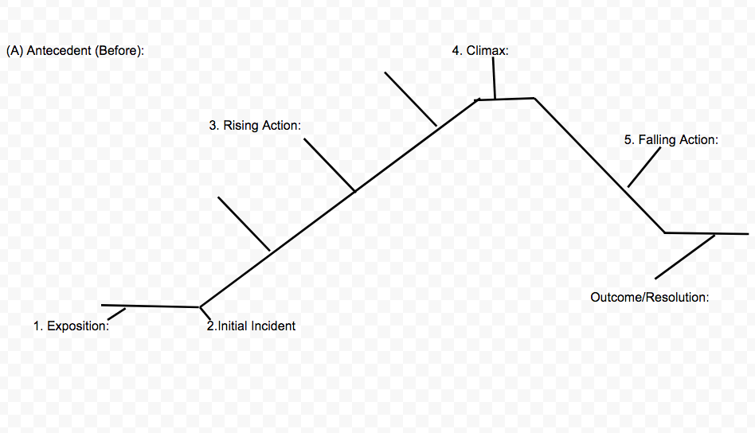
Person + External/Internal Conflict + Change (or Inability to Change) = Effects on Self and/or Others
Character(s) Traits and Motives: ______________________________________________________________________________________________________________________________________________________________________________________________________________________________________________________________________________________________________________________________________________________________________________________________________________________________________________________________________________________________________________________________________________________________________________________________________________________________________________________
Important Quotes and Who Said It:
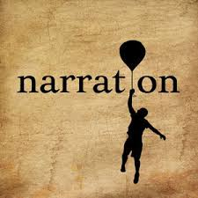
________________________________________________________________________________________________________________________________________________________________________________________________________________________________________________________________________________________________________________________________________________________________________________________________________________________________________________________________________________________________________________________________________________________________________________
__________________________________________________________________________________________________________________________________________________________________________________________________________________
Techniques: ____________________________________________________________________________________________________________________________________________________________________________________________________________________________________________________________________________________________________________________________________________________________________________________________________________________________________________________________________________________________________________________________________________________________________________________________________________________________________________________________________________________________________________________________
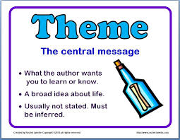
(Central message about society, people, life, etc.)
__________________________________________________________________________________________________________________________________________________________________________________________________________________________________________________________________________________________________________________________________________________________________________________________________________________________________________________________________________________________________________

