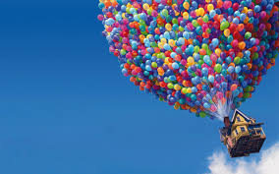
UP

As you watch the film clips, quickly whitedown observations.

 | Ellie and Carl’s Relationship | After
1. Lighting
2. Sound
3. Types of Camera Shots: is the camera from above, below, stratforward? Are things close up, or far away, or balanced?
4. Shapes/Symbols? You might have to rewatch for this one.

