Critical/Analytical Practice
For 5 out of the 7 topics listed below, construct a thesis statement(s) that consists of a deep action + consequence, and that explores the physical, psychological, or philosophical changes of a character in one of the short stories we have read. REMEMBER TO ADDRESS THE ENTIRE TOPIC QUESTION!
Remember to try and incorporate a technique (characterization, paradox, symbol, metaphor, etc) if you can. Do not force it, as doing so incorrectly can take away from the validity of your thesis. Doing so correctly, however, can show thoughtfulness/insight.
Sample thesis statements:
Bad: Tim O’Brien realizes that he cannot do what he wants to do, and instead does what society expects. (P)
OK: The author shows that people sometimes have to give up their desires because they don’t fit with society. (L-S)
Better: In the text, the author shows that when people desire something that doesn’t fit with society’s moral expectations, they will choose to conform instead of doing what they want to do because they want to avoid the negative emotions that come with it. (S)
Best: In the short story “On the Rainy River”, author Tim O’Brien utilizes the paradoxical duality of the narrator’s desires to suggest the idea that sometimes an individual’s desires conflict with the rigid moral expectations of society. This incongruence leads to shame and guilt, which will inevitably pressure the individual to conform to social expectations in order to maintain their desired place within society.(PF-E)

Possible Techniques:
-Character development (traits/motives/desires/challenges/CHANGE physical, emotional, philosophical)
-Character types (dynamic/flat/static/foil/ etc.)
-Actions and consequences
-Symbolism and motifs
-Time and place
-Archetype
-Shadowself
-Irony
-Conflict
-Literary Devices

YOU MUST discuss HOW or WHY the character changes (psychologically, philosophically, or physical) or stays stagnant, AND what is the impact (personal, others, or societal).
Examples: Given Topic: Adversity
Given the general topic of adversity a thesis statement may be:

In the play A Doll’s House, Heinrich Ibsen‘s use of character development suggests the idea that adverse situations have the power to blow the monotonous existence of one’s life to pieces and consequently may spur a search for personal identity.
Note: the basic parts
a) title- A Doll’s House
b) author’s name – Heinrich Ibsen
c) genre – play
d) technique / character development
e) topic – adversity
f) focus/controlling idea - Adverse situations have the power to blow the monotonous existence of one’s life to pieces and consequently may spur a search for personal identity.

Sample Thesis statements
1. In the short story “Gaston,” William Sarayan makes powerful use of character development to suggest the idea that appearances are frequently unreliable and do not reveal one’s inner self. (psychological)

2. In Shakespeare’s play Hamlet, the title character is used to demonstrate the idea that one must discover his own moral beliefs before he sets out to accomplish his goals. (philosophical)
3. Through the contrasting characters of Willy and Biff, Arthur Miller in the modern drama Death of a Salesman, examines the idea that for some people, the desire to escape the harshness of life is stronger than the need to confront reality. (psychological)

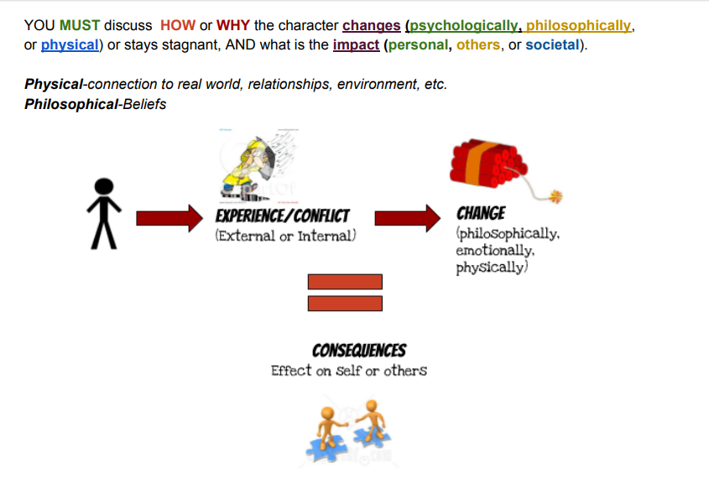
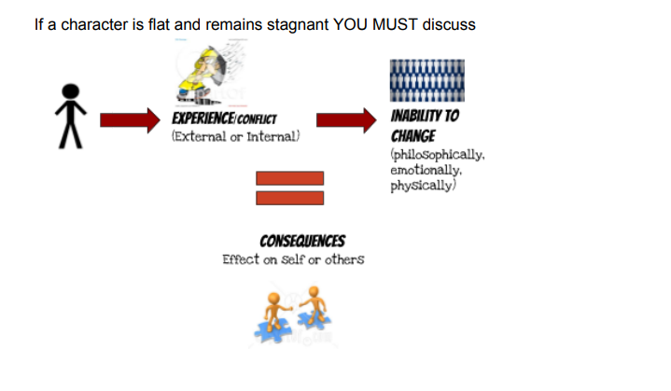

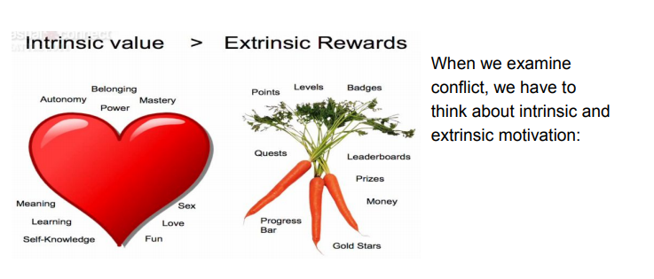

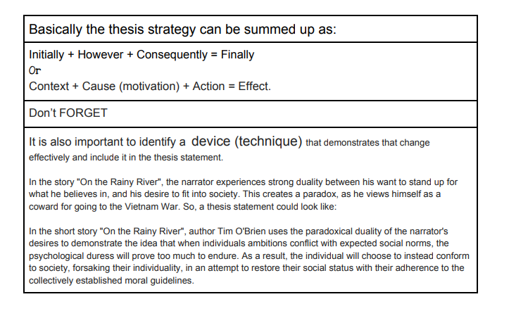

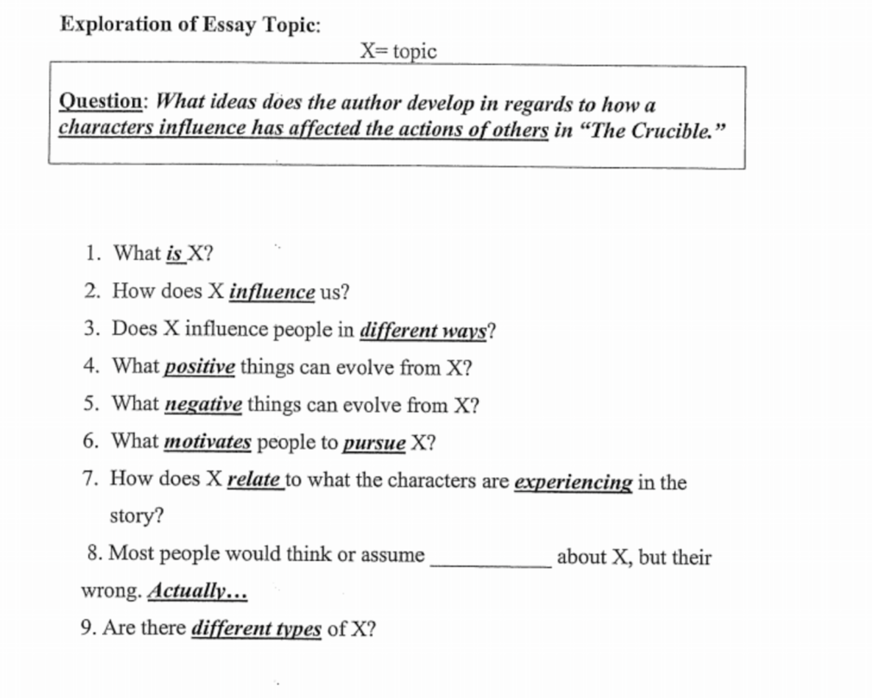

- What does the text suggest to you about how individuals deal with change in their quest for self-fulfillment?
Own words: ______________________________________________________________________________
Key Word: _______________. Synonyms: __________, ___________,_____________.
Key Word: _______________. Synonyms: __________, ___________,_____________.
Initially | However | Consequently | Finally
or
Character | Experience/Conflict | Change (type) | Result/effect
or
Circumstance | Action | Consequence/result
Thesis: In the _________, ___________, ______________________________
(genre) (title) (author’s name)
use of_______________ suggests the idea that______________________________.
(technique/ character development) (topic & student’s focus/controlling idea)

_______________________________________________________________________________________________________________________________________________________________________________________________________________________________________________________________

- What does the text suggest to you about how limitations can impact an individual’s resolve in the face of adversity?
Own words: ______________________________________________________________________________
Key Word: _______________. Synonyms: __________, ___________,_____________.
Key Word: _______________. Synonyms: __________, ___________,_____________.
Initially | However | Consequently | Finally
or
Character | Experience/Conflict | Change (type) | Result/effect
or
Circumstance | Action | Consequence/result
Thesis: In the _________, ___________, ______________________________
(genre) (title) (author’s name)
use of_______________ suggests the idea that______________________________.
(technique/ character development) (topic & student’s focus/controlling idea)

_______________________________________________________________________________________________________________________________________________________________________________________________________________________________________________________________

- What does the text suggest to you about the ways in which individuals struggle to restore honour and certainty?
Own words: ______________________________________________________________________________
Key Word: _______________. Synonyms: __________, ___________,_____________.
Key Word: _______________. Synonyms: __________, ___________,_____________.
Initially | However | Consequently | Finally
or
Character | Experience/Conflict | Change (type) | Result/effect
or
Circumstance | Action | Consequence/result
Thesis: In the _________, ___________, ______________________________
(genre) (title) (author’s name)
use of_______________ suggests the idea that______________________________.
(technique/ character development) (topic & student’s focus/controlling idea)

_______________________________________________________________________________________________________________________________________________________________________________________________________________________________________________________________

- What does the text suggest to you about the interplay between empathy and personal resolve?
Own words: ______________________________________________________________________________
Key Word: _______________. Synonyms: __________, ___________,_____________.
Key Word: _______________. Synonyms: __________, ___________,_____________.
Initially | However | Consequently | Finally
or
Character | Experience/Conflict | Change (type) | Result/effect
or
Circumstance | Action | Consequence/result
Thesis: In the _________, ___________, ______________________________
(genre) (title) (author’s name)
use of_______________ suggests the idea that______________________________.
(technique/ character development) (topic & student’s focus/controlling idea)

_______________________________________________________________________________________________________________________________________________________________________________________________________________________________________________________________
- What does the text suggest to you about the ways in which individuals struggle to maintain integrity when faced with injustice?
Own words: ______________________________________________________________________________
Key Word: _______________. Synonyms: __________, ___________,_____________.
Key Word: _______________. Synonyms: __________, ___________,_____________.

Initially | However | Consequently | Finally
or
Character | Experience/Conflict | Change (type) | Result/effect
or
Circumstance | Action | Consequence/result
Thesis: In the _________, ___________, ______________________________
(genre) (title) (author’s name)
use of_______________ suggests the idea that______________________________.
(technique/ character development) (topic & student’s focus/controlling idea)

_______________________________________________________________________________________________________________________________________________________________________________________________________________________________________________________________
- What does the text suggest to you about the significance of idealism and truth in an individual’s life?
Own words: ______________________________________________________________________________
Key Word: _______________. Synonyms: __________, ___________,_____________.
Key Word: _______________. Synonyms: __________, ___________,_____________.
Initially | However | Consequently | Finally
or
Character | Experience/Conflict | Change (type) | Result/effect
or
Circumstance | Action | Consequence/result
Thesis: In the _________, ___________, ______________________________
(genre) (title) (author’s name)
use of_______________ suggests the idea that______________________________.
(technique/ character development) (topic & student’s focus/controlling idea)

_______________________________________________________________________________________________________________________________________________________________________________________________________________________________________________________________

- What does the text suggest to you about the human need to make a commitment or renounce a course of action?
Own words: ______________________________________________________________________________
Key Word: _______________. Synonyms: __________, ___________,_____________.
Key Word: _______________. Synonyms: __________, ___________,_____________.
Initially | However | Consequently | Finally
or
Character | Experience/Conflict | Change (type) | Result/effect
or
Circumstance | Action | Consequence/result
Thesis: In the _________, ___________, ______________________________
(genre) (title) (author’s name)
use of_______________ suggests the idea that______________________________.
(technique/ character development) (topic & student’s focus/controlling idea)

_______________________________________________________________________________________________________________________________________________________________________________________________________________________________________________________________

