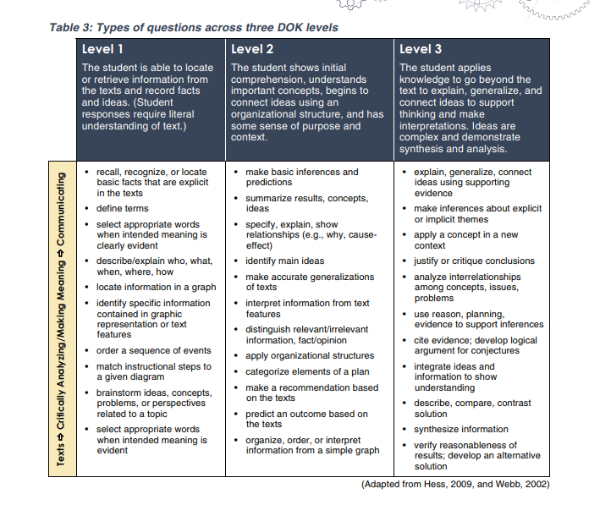

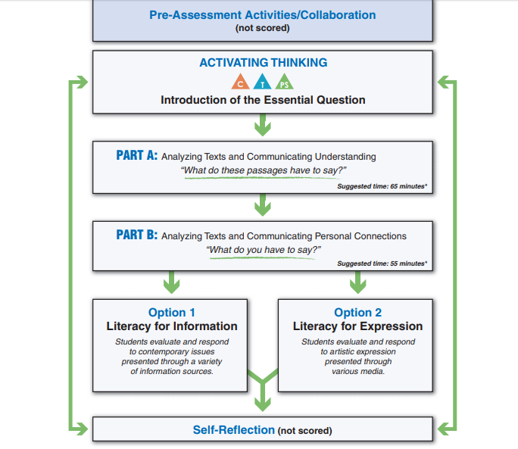

Activate Thinking
Brainstorm

Part A: Analyzing Texts and Communicating Understanding
What do these TEXTS have to say? (Summarize/Understand)

Part B: Analyzing Texts and Communicating Personal Connections
What do YOU have to say? (Interpret/ Analyze/ Respond)

Option 1 | Option 2
Literacy for Information  Students evaluate and respond to contemporary issues presented through a variety | Literacy for Expression Self-Reflection  Students evaluate and respond to artistic expression presented through various media.
Option: _______________________
- __________________________________________________________________________________________________________________________________________________________________________________________________________________________________________________________________________________________________________________________________________________________________________________________________________________________________________________________________________________________________________________________________________________________________________________________________________________________________________________________________________________________________________________________________________________________________________________________________________________________________________________________________________________________________________________________________________________________________________________________________________________________________________________________________________________________________________________________________________________________________________________________________________________________________________________________________________________________________________________________________________________________________________________________________________________________________________________________________________________________________________________________________________________________________________________________________________________________________________________________________________________________________________________________________________________________________________________________________________________________________________________________________________________________________________________________________________________________________________________________________________________________________________________________________________________________________________________________________________________________________________________________________________________________________________________________________________________________________________________________________________________________________________________________________________________________________________________________________________________________________________________________________________________________________________________________________________________________________________________________________________________________________________________________________________________________________________________________________________________________________________________________________________________________________________________________________________________________________________________________________________________________________________________________________________________________________________________________________

