Name:

Create Your Lord of the Flies Mask Assignment

MASK:
Your task is to complete your own mask by designing and constructing a mask that represents a part of yourself you normally do not show. Please make your mask as detailed as possible.

You will need to create a mind map or word web that will help you organize what self you want to portray on your mask.

In addition, make sure to plan out your mask on paper as a draft version before you begin constructing your own mask using the blank mask.

WRITING PART 1:
Once you have completed your mask, you will need to write two paragraphs. The first paragraph will explain what your mask represents as a character of yourself and your second paragraph will explain how you believe others will perceive you when you are wearing your mask. (Think: Shadow-Self)
WRITING PART 2:
You will create a 500 word story that is based off of your mask.
Or
You will create a 500 word story that is based off or a response to the theme to Lord of the Flies.
Your story needs to have a strong and interesting plot, as well as descriptive writing.

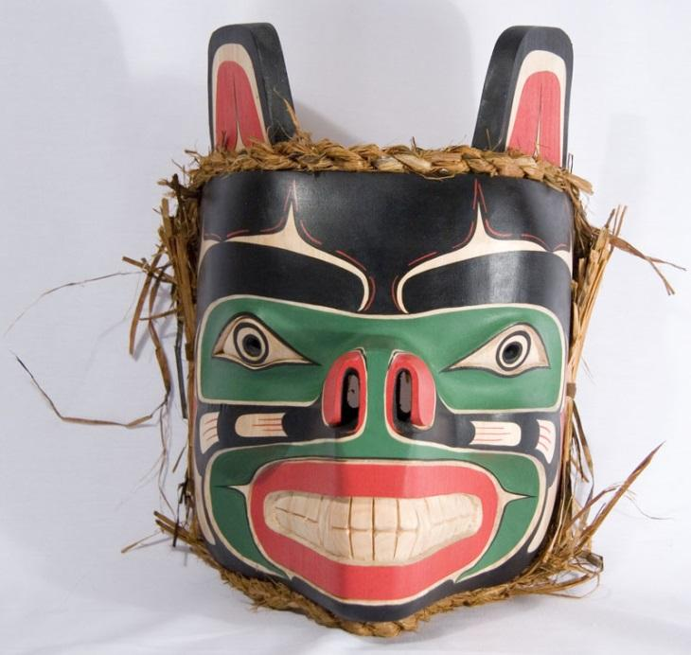
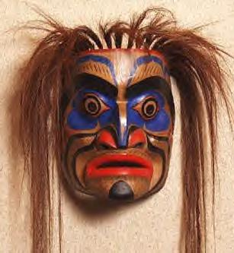

Mask Rubric
Excellent Proficient Satisfactory Limited Poor
Connect Self to his/her mask. | Student’s connection to the mask is insightful. The student’s ideas are perceptively explored. Support is precise and effective. | Student has a well-considered connection to the mask. The student’s ideas are thoughtfully explored. Support is specific and relevant. | A defensible connection to the mask is demonstrated. The student’s ideas are straightforwardly explored. Support is general. | A connection to the mask is partially demonstrated but not maintained. Student’s ideas are unclearly explored. Support is overgeneralized. | A minimal understanding of the topic is demonstrated. The student’s ideas are underdeveloped, and/or incomprehensible. Support is irrelevant.
Presentation, content, and choice. | Student’s mask is engaging. Stylistic choices are precise and relevant. | Stylistic choices are specific and frequently effective. | Stylistic choices are adequate and occasionally effective. | Stylistic choices are inappropriate, imprecise, and often ineffective. | There are often vague, ineffective, or irrelevant.

Story Rubric
 | Excellent | Proficient | Satisfactory | Poor | Limited
Thought and support | Student’s piece shows considerable planning and has a unified focus. Overall, the student shows a comprehensive understanding of the topic. | Student’s piece shows substantial planning and has a unified focus. The student demonstrates a strong understanding of the topic. | Student’s piece is somewhat focused. There is an understanding of the topic; however, it may lapse in unifying effect. | Student’s piece is generalized in its focus and is scattered in its  Understanding. | Student’s piece shows a minimal understanding. The ideas and the focus are underdeveloped.
Presentation | Student’s voice is engaging and tone is confident. Student’s choices are effective and polished. | Student’s voice is engaging and tone is often confident. Student’s choices are frequently effective and fairly polished. | Student’s voice is distinct and appropriate. Student’s choices are occasionally effective and somewhat polished. | Student’s voice is inconsistent and/or inappropriate. Student’s choices are inappropriate not polished. | Student’s voice is confused and/or inappropriate. Student’s choices are ineffective.  Or there is insufficient content to mark.

Lord of the Flies Essay Questions

Please answer one of the following questions in essay format.

- Using Lord of the Flies as your evidence, explain if human beings are inherently evil?
Or
2. Choose one of the following: Freudian, religious, or animalistic lens and explain how the story of Lord of the Flies can be read through the chosen perspective.
Or
- What is the symbolic nature of the conch? What does it reveal about human nature?

You will be marked according to the functional writing rubric.

