Gr. 10 Study Sheet - Final Exam 2019
Please continue to also look over your class notes.
There will not be any Wordly Wise words; however, you will need to have vocabulary skills.

TERM | YOUR DEFINITION | EXAMPLE | PICTURE
Repetition
Alliteration
Consonance
Assonance
Motif
Juxtaposition
Paradox
Oxymoron
Euphemism
Hyperbole
Simile/Metaphor
Personification
Sensory Language
Denotative
Connotative
Shakespeare
Iambic pentameter
Hamartia
Quotation Rules
Simple Sentences
Parts of Speech
Apostrophes
Capitalization and punctuation
Compound Sentences
Complex Sentences
Phrase
Clause
Coordinating Conjunctions

Subordinating Conjunctions

Colons
Semi Colons
Active Voice
Introductory Phrase
Parallel Structure
Titles: Larger works
(Films, novels, etc.)
Titles: shorter works
(Magazine article, song, short story, poem etc.)
Capitalization of Titles

Correcting Grammatical Errors
Comma Splices
Fragmented Sentences

Run-on Sentences

General Writing
Paragraph Structure:
Direct Quotes
Indirect Quotes
Argumentative Essay
Controlling Idea
Unifying Effect
Transitions
Short Story and Hamlet
Term | YOUR Definition | Example | Picture
Linear vs flashback Plot Sequence
Antecedent Action
Initial Incident
Rising Action
Suspense
Climax
Falling Action
Demonte
Resolution
Types of Conflict
Setting
Foreshadowing
Theme
Types of Irony
Symbolism
Motif
Types of Figurative Language
Types of Character
Motive
Traits
Indirect Characterization
Direct Characterization
Show Don’t Tell
Sensory Language
Allusion
Parable
Allegory
Soliloquy
Monologue
Aside

Title, Author, and Genre:

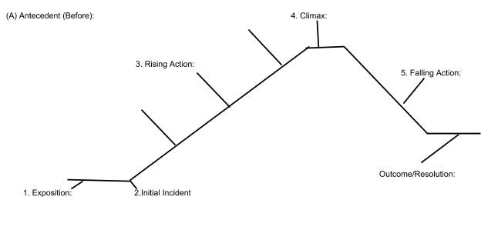

Character(s) Traits and Motives:

__________________________________________________________________________________________________________________________________________________________________________________________________________________________________________________________________________________________________________________________________________________________________________________
Important Quotes and Who Said It:
__________________________________________________________________________________________________________________________________________________________________________________________________________________________________________________________________________________________________________________________________________________________________________________

Techniques: 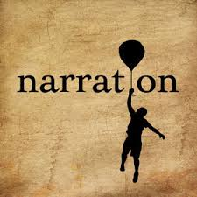
__________________________________________________________________________________________________________________________________________________________________________________________________________________________________________________________________________________________________________________________________________________________________________________
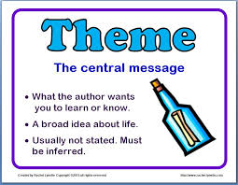
Theme(s):
________________________________________________________________________________________________________________________________________________________________________________________________________________________________________________________________________________________________________
________________________________________________________________________________________________________________________________________________________________________________________________________________________________________________________________________________________________________

