Go to http://www.empireonline.com/features/film-studies-101-camera-shots-styles
You must use all 3 pages to find your answers

Camera Shots

 | Description and Effect | Picture
The Aerial Shot | A shot taken from outside/exterior and in the air.  It helps to establish a location. | 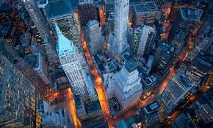
The Close Up Shot
The Medium Shot
The Establishing Shot
The Low Angle Shot
The High Angle Shot
The Over the Shoulder
The Point of View Shot
The Dutch Tilt Shot
Also known as the oblique shot

